**Perennial Bloom Calendar**

Designing for Four Seasons of Flowers

Visit a local gardening center in spring and you will find a myriad of perennial plants all in full flower. If you were to purchase a selection of these and plant them at home, chances are you would have lots of flowers for a few weeks or so, but then when summer rolled around your yard would have lost a lot of its bloom. That’s because for the most part, the showiest, most eye-catching plants in the nursery are for sale during their **peak bloom time**. If you shop a few times throughout the seasons, you’ll see different plants blooming at different times. With a little planning, you can design a garden with four seasons of flowers. This guide aims to help. We have selected a number of common perennial flowering plants and mapped out their general flowering times.

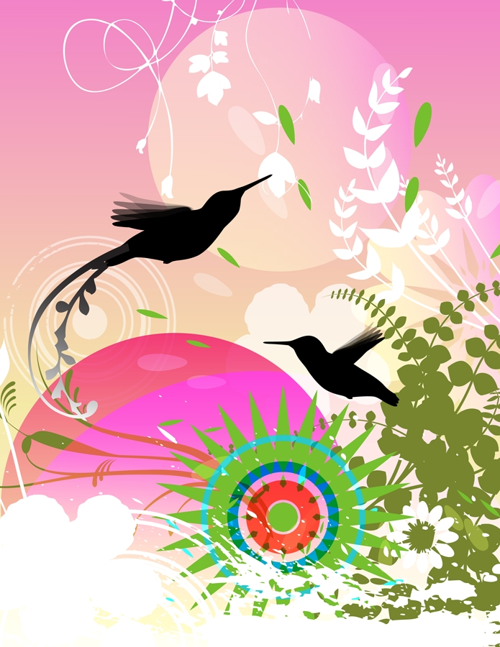

**Dreaming of a garden filled with nearly never-ending flowers?**

With a little planning, your garden can have blooms almost all year long. Unlike summer annuals that bloom consistently over many months, perennials generally have a window of time when their flower flushes appear. By following this guide, you can design a perennial garden that will provide four seasons of interest.



Compiled by Corina Reynolds Stearns

**Even though each plant has its own common bloom time, there are many factors that affect when perennial flowers will appear:**

**Seasonal issues:** Every season is different. If, for instance, we have a very cold spring, this will probably push back the bloom times of many early season flowers. Alternatively, if we have a very warm spring, many plants will bloom early. A hot, dry summer with drought conditions may also cause a change in bloom times.

**Age of Plant:** More mature plants tend to put out more blooms over a longer period.

**Culture:** Following the recommendations for amount of sun, water, and fertilizer is very important to keep perennials blooming their best. If a sun-loving plant is put in too much shade, it will not perform well. If a plant does not get the amount of water or nutrients it needs it also will not perform.

**Extending Bloom Times:** Sometimes plants will put out another flush of flowers if they are sheared back after the first blooms fade. Plant tags will usually tell you if this is a good idea. Deadheading spent flowers can prolong blooming almost indefinitely. Perennials also may need to be thinned or divided every few years to keep them in top form.

**Varietal Differences:** Sometimes there are many species of the same plant that will have different qualities and bloom times. Check the tags or ask if you are unsure about when a particular plant is supposed to bloom.

**Questions?** We’re always happy to help. Stop by the Information desk or email us at

**info@portlandnursery.com**

